IFG Explore

3rd Year

Term Three – Weeks Four – Six Mysteries in the Bible Spiritual
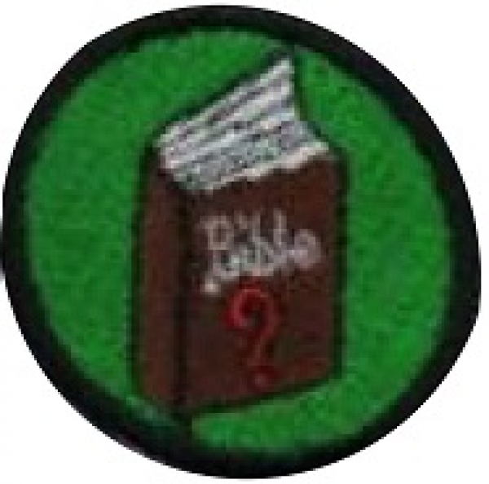
Aim: Learn about some of the Mysteries in the Bible

Preparation:
- Resources and equipment needed for the activities chosen.

SetUp:
Usual SetUp, roll call etc.

Games:
You may like to continue playing those games from the previous three weeks that the girls enjoyed.

Devotions:
The Bible is chock full of mysteries but the difference between Bible mysteries and other sort of mysteries is that we are not meant to solve Bible mysteries.

1 Corinthians Ch 13 V12 speaks about us seeing things as though we are looking into a dark mirror now, but later we will see things clearly (know the answers). The hard thing for us is to accept this.

Think of it like this. God has given us lots of gifts for no other reason than He wanted to. It is a bit like a favourite grandparent giving you a present even though it’s not your birthday or Christmas or you have done really well at school. Sometimes, secretly, we may think we don’t really deserve that present. Accepting nicely something we haven’t done anything for is called “grace”.
It is all part of the mystery……..

You will know your girls well enough by now to gauge to what level you can continue this discussion. The whole of 1 Corinthians Ch 13 has some good themes on which to build your three weeks of “spiritual” learning.
- “What does love look like?”
- “How do we put love into action in everyday life?”
- “If I am a loving person how do I show this in the way I behave?”

Jonah and the Whale:
People continually debate whether Jonah was swallowed by a fish or a whale, or whether the story really happened. Certainly God is capable of creating a special creature for such a purpose, and Jesus himself referred to Jonah during His time on earth. But debates aside, what is most important about this story is God’s wonderful mercy for everyone, even those that turn their back on Him.
God instructed Jonah to go to the evil city of Nineveh and preach. Instead of obeying God, Jonah fled on a ship in the opposite direction. During the voyage, a great storm almost destroyed the ship. Realizing his sin might lead to the destruction of the ship, Jonah instructed the sailors to throw him overboard. The storm ceased and the ship was saved.
Jonah thought he would drown in the sea. But God wasn’t through with him. He commanded a giant fish to swallow him. Inside the belly of the fish, Jonah asked God to forgive him. After three days, the fish spit Jonah onto dry land and he traveled to Nineveh as God had commanded. Satan was trying his best to destroy Jonah, but God loved Jonah and the people of Nineveh so much, He had another plan.
Check out this easy to understand story about Jonah http://www.matneywoodard.com/Humongous_Hollis.htm

Teaching Sessions:
Choose from the following activities or come up with some of your own for this three week programme:

Make certificates to give to mothers offering to do extra jobs at home.

Make some unbirthday greetings cards for the elderly

Girl to hold a mirror (looking glass) Have a piece of black fabric large enough to cover the girl and the mirror. Ask her to describe how well she can see what is in the mirror. Now remove the fabric and shine a light in such a way that she can now see very well what is in the mirror.

Songs:
Learn some songs showing God’s love;
“This Little Light of Mine, I’m going to make it Shine”.
We are each to be like a light in the world. (Matthew Ch 5 v14)
Tell the girls that some people are described as “It’s like a light turning on when she walks into the room”. What can that mean? Have girls practice walking in to the room being like a light shining for Jesus / cheering every one up.

Many of the girls will know favourite traditional Christian children's songs such as "Jesus Loves Me" or "Jesus Loves the Little Children." Incorporating sign language with the songs adds a further dimension to engage young minds and bodies and unpacks for them the “mystery” of sign language that deaf people use. For NZ sign language go to http://www.deaf.org.nz/resources/learn-new-zealand-sign-language/fingerspelling-alphabet
here you can download a PDF of the signs used in NZ by the deaf.

Totem Pole

Give girls about a dozen circles of different sizes. Tell them to draw the face or write the name of people that they love on each circle. Explain that they should write those most important to them, such as their mum and dad, on the bigger circles and other people they love, such as their cousins and friends from school, on the smaller circles. When all of the circles are done, have the girls glue them to an empty paper towel roll, with the smallest circles on the bottom, and the largest circles near the top. Give them a heart, larger than any of the circles, and tell them to glue it to the top of the tube. Explain that we should love those close to us in Christian love, which means putting them second to God. Write on the large heart "Love God Above All Else."

Love letter from God:
The Bible describes many instances of God's love. Helping the girls to understand how God loves them, helps them to know how to show love to others.. Allow girls to give input on their own honest feelings concerning compassion/love to others. Sometimes it's hard for children to understand why anyone should be nice to someone who's not nice back, and yet loving the unlovable is exactly the way God's love is shown to us.
Cut out enough paper hearts for two for each girl. Print scriptures from 1 John 4:8-19 or other scriptures of your choice that talk about how God loves us. Glue the verses to half of the hearts. Hide these hearts around the room/hall. Leave the other half blank and let the girls decorate them. Once they have decorated their heart, they can then go on a “mystery hunt” to find the other hearts. Once found, gather the girls together in a group and talk about getting love letters or notes on special occasions e.g. their birthday etc. Hold up a Bible and talk about hot it is God’s love letter to us. Now, get the girls to read out the scripture on the heart they found. . When you come across the word "God," have girls point up to the sky. When you read the word "love," have children point to the Bible. Once all the hearts have been read, the girls can paste them to the back of the hearts they decorated. Now they have their own love letter from God.

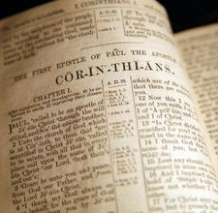
Thumbody Loves Me

Make thumbprint art on paper. You can choose from several thumbprint creations, and then add details with a black marker. For a thumbprint caterpillar, add legs and face to the caterpillar. For a thumbprint butterfly, use four prints of the same color and add antenna and a body. Make a thumbprint sun, mixing yellow, red and orange. A thumbprint flower will use four or five prints for the petals and two green leaf prints. Add a centre and a stem. All art work can include the saying "Thumbody loves me, God, that's who!"

Mobiles:

Make a mobile based on the theme of LOVE. Dangle from a wire hanger pictures of different objects, images or words that symbolize LOVE and showing LOVE to others. You may want to provide some outlines for them to choose from, but also give them the option of creating their own ideas as to what LOVE means to them. Cut out the images and punch a hole at the top of each image. They can then thread a string through each image and tie or tape it to the bottom of a wire hanger.

Puppets

Make puppets to teach about the love of God. Choose a Bible story relevant to your girls and then make puppets relating to this. The girls could draw the characters on heavy paper or card stock, colour their drawings, and cut them out. They can then tape their drawings to large craft sticks. Alternatively, they may cut pictures from magazines and glue the pictures to card stock. The girls could then work together to write scenarios relating to the story and then act them out.

Closing prayer

Home time & Notices:

